**CPSC 583 Programming Assignment 3**

Jordan Lee | 30002218 | April 7, 2021

**Live Demo**

<https://jordanmklee.github.io/CPSC583/A3%20-%20Modifying%20Visualization/code-assignment3/index.html>

**Sketching and Design**

Firstly, I sketched three different ways that elements can be selected (toggle, brush, and lasso):

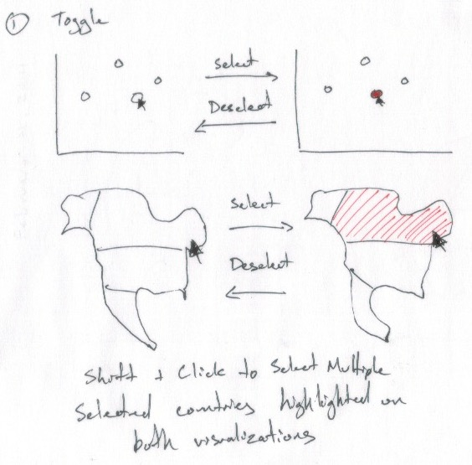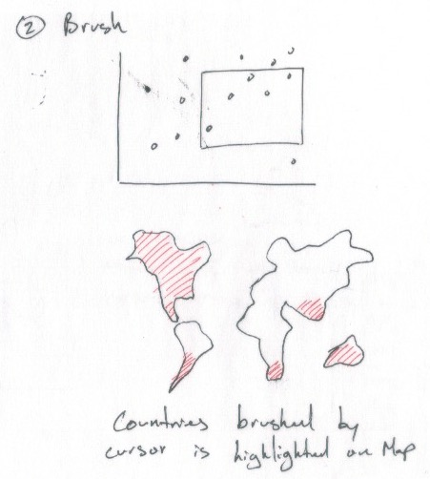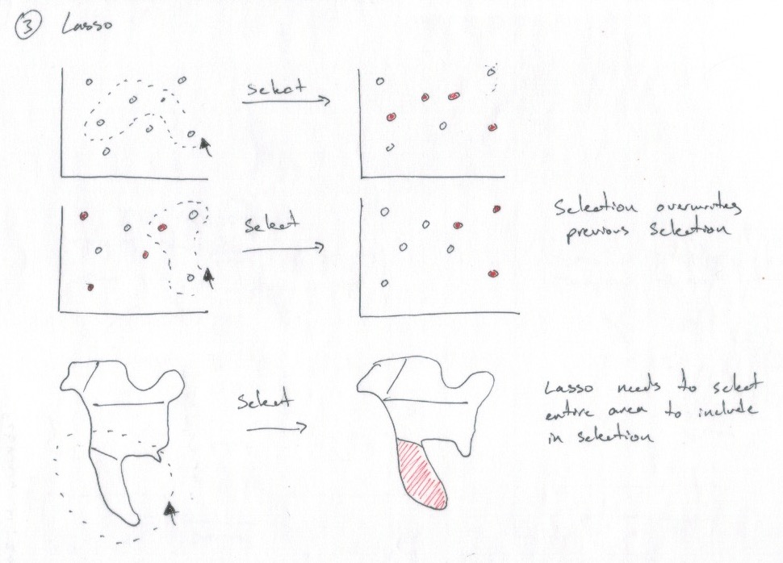

For the toggle interaction, to select elements they are individually clicked on. Selected elements change colours to denote their status, and clicking on an already selected element deselects it and reverts to the original colour.

Another interaction I sketched was brushing to select elements. The user can click-and-drag to create a rectangular brush on the scatterplot, and any dots enclosed within the rectangle are selected. The brush can then be resized or moved to make a different selection.

The last interaction sketched was a lasso, which combines aspects of both toggling and brushing. The user can click-and-drag to create an arbitrarily-shaped brush around elements, and any element that is enclosed within the brush is selected. Elements are required to be fully enclosed in the brush to be selected, eg. a brush that covers half of a country does not select it. Creating a new lasso brush deselects the previous selection, and selects the elements enclosed by the newly created brush.

For the implementation, I decided to use multiple ideas from the sketches since I found that certain methods are more effective for certain visualizations. As an example, using a toggle selection is helpful for individually selecting shapes of various sizes and locations, but on a scatterplot where the dots are clustered and small it can be difficult to accurately choose a specific dot, and to select many dots at once. Another idea considered was brush selection, which solves the problems of toggle selection for a scatterplot, but was not as appropriate for a map since it can cause issues when selecting countries that are not adjacent to one another.

Therefore, selection of one or more elements in the scatterplot was accomplished by brushing, and selection of one or more elements in the map was achieved using toggle selection.

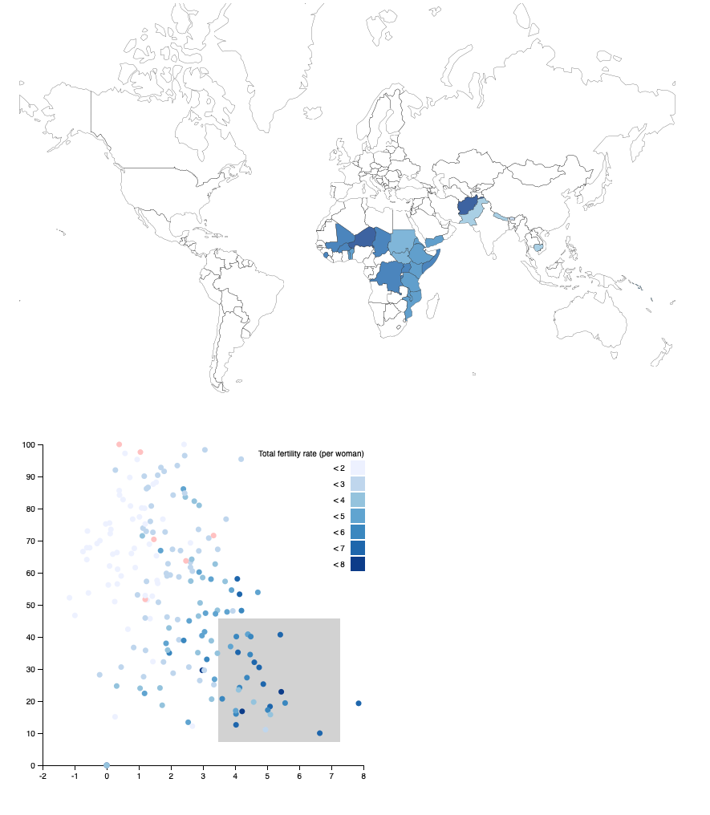**Implementation - Scatterplot Selection**

(Right)

By creating a brush on the scatterplot visualization, the selected dots’ countries are highlighted on the map, while the countries not selected have no colour. The original colours are maintained to retain the encoded data.

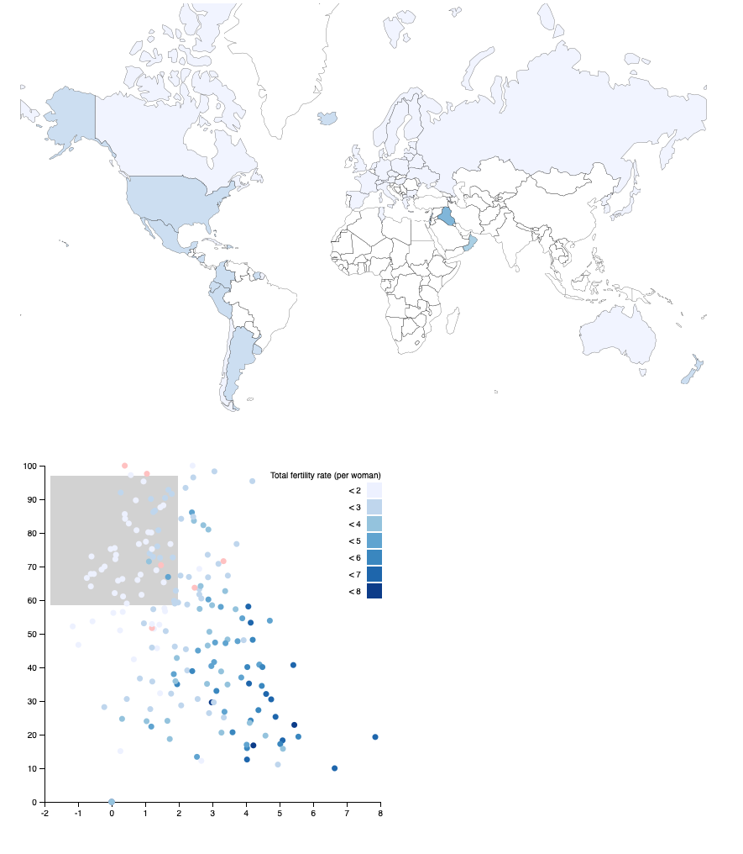

(Left)

Moving the brush on the scatterplot updates the map with the current selection.

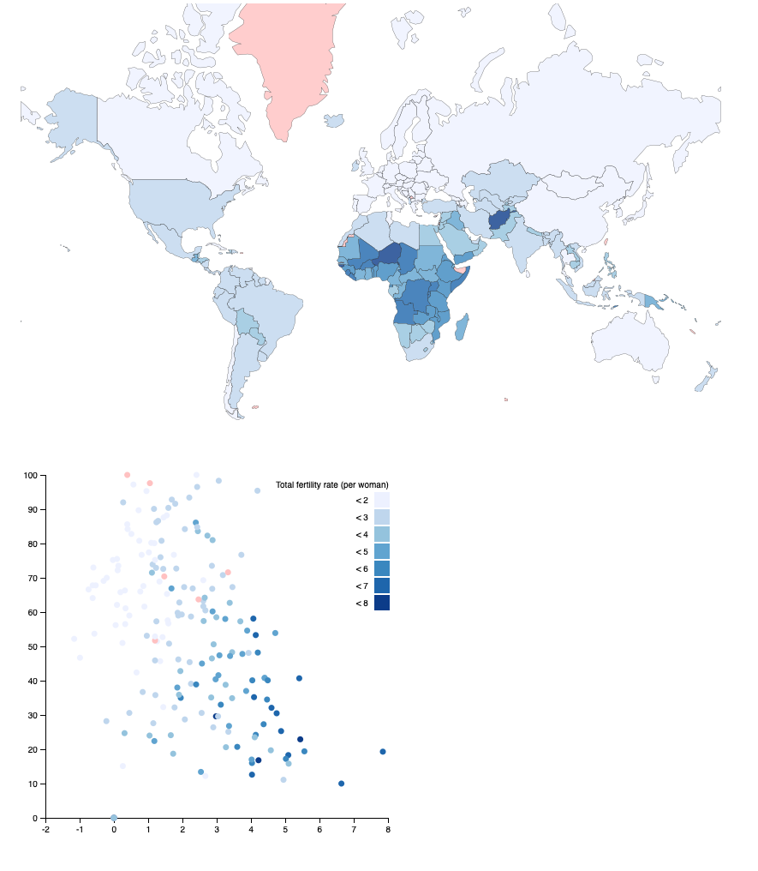

(Right)

Clicking outside of the brush area clears the selection, and reverts the map’s colours to show all country data.

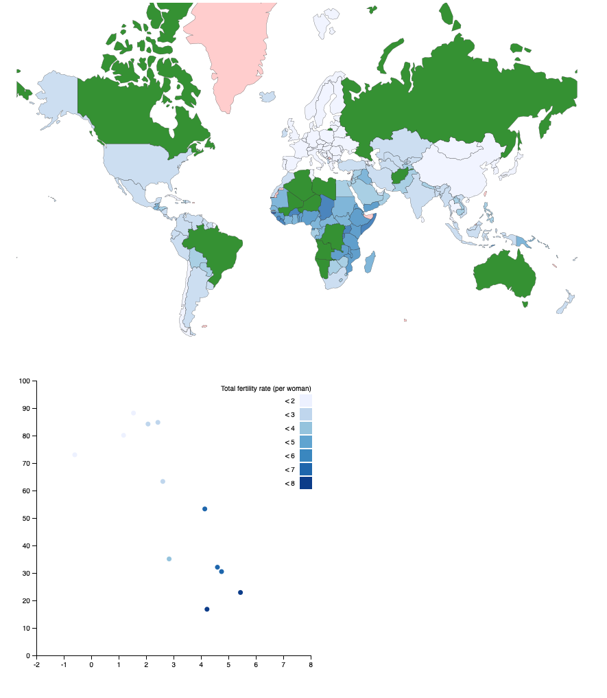**Implementation - Map Selection**

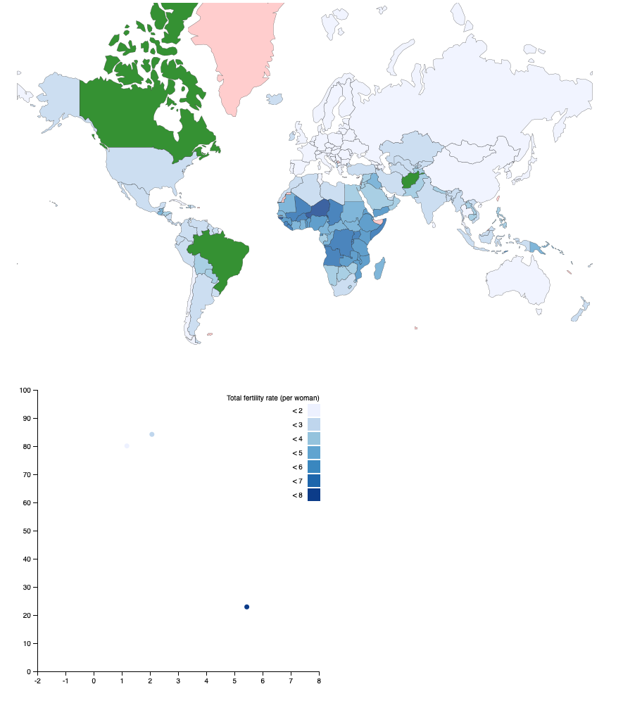(Right)

Countries on the map can be clicked on to be selected, and change in colour to denote their state. When one or more countries are selected, the scatterplot updates to only show the selected countries.

(Left)

Countries are deselected by clicking again on them, and reverts to the original colour. Again, the scatterplot updates to only show the selected countries.

As well, the map can be double-clicked at any time to clear map selections.

**Reflection**

Overall, the implementation reflects what I intended after sketching. The brushing updates the map with the selected countries, and the toggle selection for the map shows effectively which countries are shown in the scatterplot. There are a few shortcomings of this implementation that I would change:

1. Although the brightness of blues is effective in creating a scale, the lighter blues can be hard to see against the white background. I would either change the background or change blue range so it is more visible when only countries with low total fertility rate are selected.
2. The green is a good contrast from the blue and red, but I would have the selected countries vary in brightness of greens to still encode the existing data.
3. Smaller countries on the map can be difficult to see and select, which can be remedied by adding zoom functionality so that they can be more easily selected.